Did you know? The average water molecule stays nine days in the atmosphere!

Name________KEY_________________________________
Science TEKS: 3.11, 5.1, 5.2, 5.3, 5.4, 5.5, 5.6
Math TEKS: 5.11, 5.14, 5.15
Lesson Three:
Atmospheric Gases and Their Cycles

Overview. You have already learned a little about Earth’s atmosphere – its five layers, and some of its important properties like temperature and wind. Now we wonder, What types of gases make up the air around us? Today, we will learn about some of the important types of gases that make up the atmosphere. We will also learn about the cycles that enable those substances to move around the Earth and its atmosphere.

What are the five main gases that make up the atmosphere?

- _Nitrogen_____________
- __Oxygen_____________
- __Argon____________
- __Water Vapor___________
- _Carbon Dioxide______

WATER CYCLE
Each of the words below is a process in the water cycle. Define each word and label it in the figure below.
- Evaporation: Heat energy from sun causes liquid water to convert (evaporate) into water vapor gas
2) Transpiration: Water vapor is released from vegetation

3) Condensation: Water vapor converts (condenses) back into liquid water
4) Precipitation: Water falls from the sky as rain, snow, sleet, or hail

5) Infiltration: Water vapor moves from the surface into the ground water.
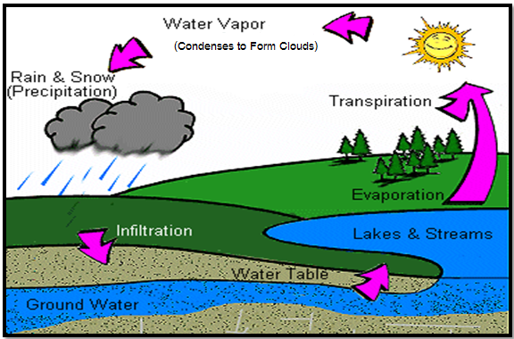
Condensation
Credit: http://www.dnr.state.wi.us/org/caer/ce/eek/earth/groundwater/images/groundwater.gif
HUMIDITY
Humidity is a measurement of how much
_water vapor__ is in the air.

Which instrument do we use to measure humidity?
Digital hygro-thermometer

CLOUDS

In what layer of the atmosphere do you find clouds?
Troposphere

Which types of clouds did you see outside today?

Answers may vary

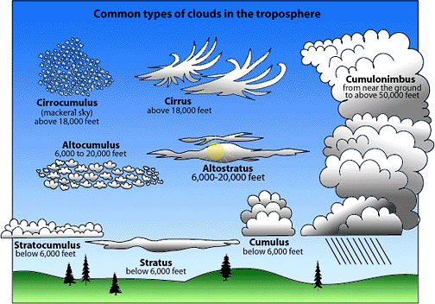
Credit: http://www.stmarysmedia.co.uk/jb01/project/images/cloudchart.gif

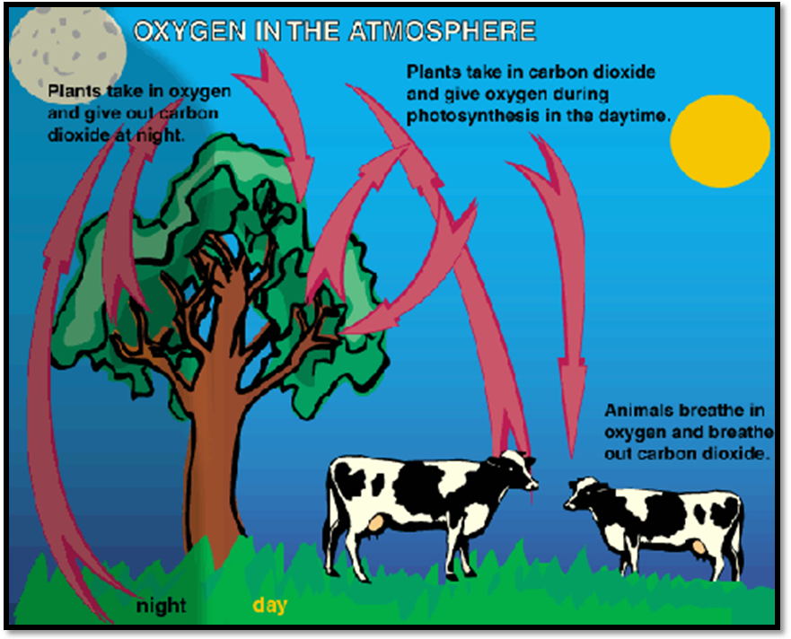

Oxygen Cycle
Credit: http://www.kidsgeo.com/geography-for-kids/0160-the-oxygen-cycle.php

What percent of the atmosphere is made up of oxygen?
21%

Why is oxygen important to animals?
Oxygen is needed by animals to breathe and to carry out living functions.

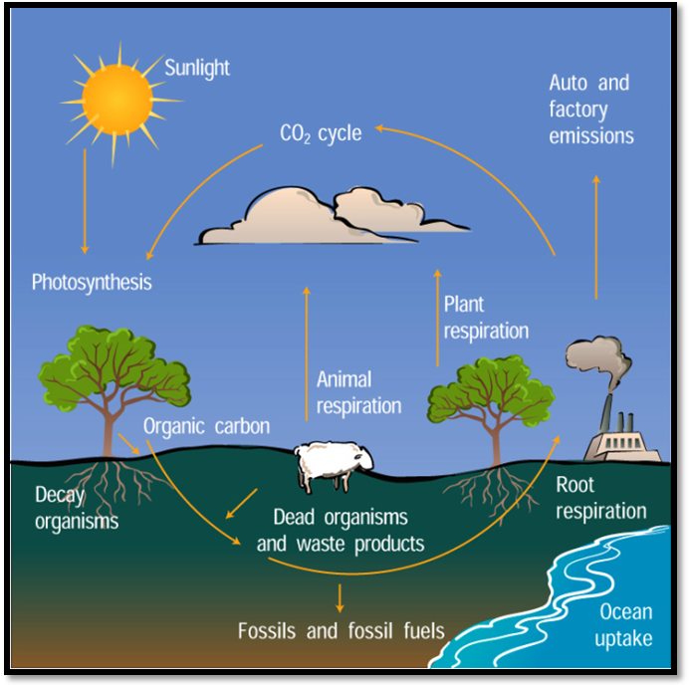
The Carbon Cycle
Credit: http://www.windows.ucar.edu/tour/link=/earth/climate/images/carboncycle_jpg_image.html&edu=elem
In which process do plants take carbon dioxide from the atmosphere?
Photosynthesis

In which process do plants, animals, and roots release carbon dioxide into the atmosphere?
Respiration
How do autos and factories affect the carbon cycle?
Cars and factories emit carbon dioxide into the atmosphere.

What did you find cool or
surprising that you learned about
the atmosphere today?
Describe a few new facts that you learned.
____________________________________________________________________________________________________________________________________________________________________________________________________________________



